CSC and Peripheral Crate Timing Documentation

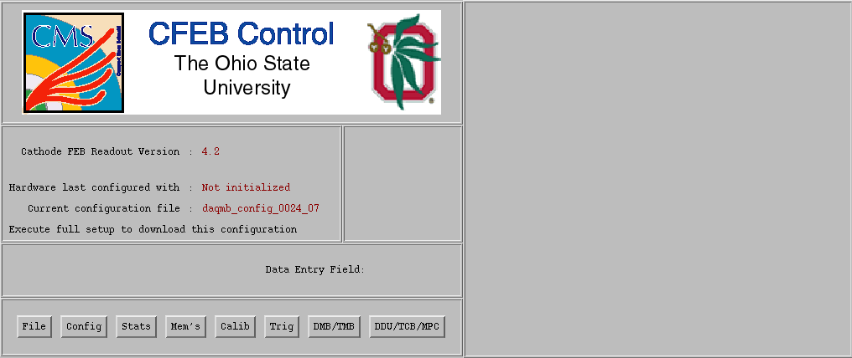
The following is an outline of the usual CSC and peripheral crate timing procedure, giving the necessary steps sequentially. To start the DAQ software, run the executable “cfeb_control” located in the fast_daq/daqmb/ directory. Note that it will be necessary to close and recompile cfeb_control after most of the timing operations. To recompile cfeb_control, type “gmake” in the fast_daq/daqmb/ directory.

The menus and submenus used in this documentation are listed below for reference. From the main cfeb_control window, the following menus may be opened:

File | Config | Trig | DDU/TCB/MPC
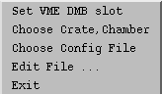 | 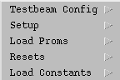 | 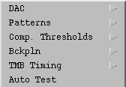 | 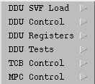

The general procedure in timing in the system is to program the hardware, start the system triggering (but not writing any data to disk) and then perform the desired timing operation. Some of the timing operations assume a continuous stream of particles (TMB PHOS4 timing, TMB Logic Analyzer timing), and adjusting timing in structured beam is much more difficult.

The following are the important submenus:
Config | Config | DDU/TCB/MPC | Trig
Setup | Resets | DDU Tests | TMB Timing
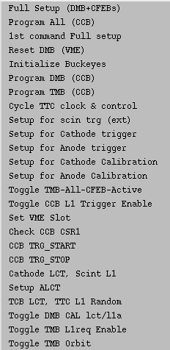 | 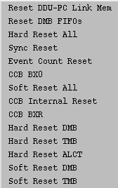 | 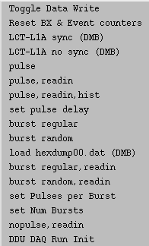 | 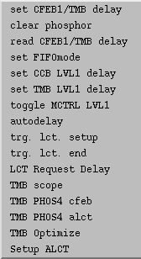

To program hardware:
- Setup – 1st command Full setup
- Setup – cathode LCT, Scint L1
- Setup – Setup ALCT
- Repeat above steps for multiple chambers (adjust VME slot).
- File – Set VME DMB Slot (or Setup – Set VME Slot)
- Then enter the number of the DMB slot in the text entry window which appears and hit <enter>. This adjusts both the DMB and TMB slots in cfeb_control.

To start triggering:
- Resets – Sync Reset
- DDU Tests – Reset BX & Event counters
- Setup – CCB TRG_START
- Resets – CCB BX0
- Setup – Cycle TTC clock & control (if using TTC)
- Setup – Toggle CCB L1 Trigger Enable

To stop triggering:
- Setup – Toggle CCB L1 Trigger Enable
- Setup – Cycle TTC clock & control (if using TTC)
- Setup – CCB TRG_STOP
TMB PHOS4 timing:
Because the ALCT gets its clock from the TMB, the first step is to time in the connection between TMB and ALCT, which is multiplexed up to 80 MHz from the usual 40 MHz clock of the system. Similarly, the CFEB boards also receive a multiplexed signal from the TMB, which includes the LCT pulse. The LCT pulse to the CFEBs is necessary to set the global L1A signal (via the CCB) to the system, and thus must be done before adjusting the timing on the CFEBs (see CFEB Timing, below). Timing in the multiplexed signals refers to adjusting a delay in the phase of the transmission so that the serially transmitted bits are interpreted correctly after de-multiplexing. In the 2001 version of the TMB, the delay chips are called “PHOS4 chips,” hence the name of this timing section.

To time in the multiplexed signals to the ALCT, setup the system to trigger and then run “TMB PHOS4 alct” from the “Trig – TMB Timing” menu. After about 5 minutes, the software will output to the screen three 2-D scatter plots of the PHOS4 delay chip settings for tx and rx to the ALCT, where the tx clock (lower bits) are on the y-axis and the rx clock (higher bits) are on the x-axis. The first plot is a scan solely over tx and the third is a combination of tx and rx (ignore the second plot). In the first plot, values of zero represent delays where the setting is an acceptable timing, and non-zero values represent unacceptable timing. Choose the delay at the center of the acceptable tx region from this plot (see below).

Example of first scatter plot output of ALCT PHOS4 timing (modulo some channels that do not fit on the page). The middle of the acceptable tx region is 0x05:

0000 0000 0000 0000 0000 0000 0000 0000 0000 0000 0000 0000 0000 0000 0000 0000 0000 0000 0000 0000 0000
0000 0000 0000 0000 0000 0000 0000 0000 0000 0000 0000 0000 0000 0000 0000 0000 0000 0000 0000 0000 0000 0000 0000 0000 0000 0000 0000 0000 0000 0000 0000 0000 0000 0000 0000 0000 0000 0000 0000 0000 0000 0000 0000 0000 0000 0000 0000 0000 0000 0000 0000 0000 0000 0000 0000 0000 0000 0000 0000 0000 0000 0000 0000 0000 0000 0000 0000 0000 0000 0000 0000 0000 0000 0000 0000 0000 0000 0000 0000 0000 0000 0000 0000 0000 0000 0000 0000 0000 0000 0000 0000 0000 0000 0000 0000 0000 0000 0000 0000 0000 0000 0000 0000 0000 0000 0000 0000 0000 0000 0000 0000 0000 0000 0000 0000 0000 0000 0000 0000 0000 0000 0000 0000 0000 0000 0000 0000 0000 0000 0000 0000 0000 0000 0000 0000 0000 0000 0000 0000 0000 0000 0000 0000 0000 0000 0000 0000 0000 0000 0000 0000 0000 0000 0000 0000 0000 0000 0000 0000 0000 0000 0000 0000 0000 0000 0000 0000 0000 0000 0000 0000 0000 0000 0000 0000 0000 0000 0000 0000 0000 0000 0000 0000 0000 0000 0000 0000 0000 0000 0000 0000 0000 0000 0000 0000 0000 0000 0000 0000 0000 0000 0000 0000 0000 0000 0000 0000 0000 0000 0000 0127 0572 0669 1728 0232 1380 0136 0035 0368 0787 0508 0085 0454 1056 0192 0055 0208 0878 1119 0105 1340 0776 0712 0018 0805 0899 0780 0801 0096 0793 0752 0809 0452 0752 0103 0621 0348 0128 0674 0737 0097 0728 0760 0761 0749 0792 0741 0764 0620 0772 0820 1091 0741 0556 0273 0864 0740 0336 0641 0714 0777 0793 0778 0981 0796 0265 0759 0757 0778 0832 0811 0762 0813 0556 0796 0812 0796 1132 0796 0812 0816 0616 0712 0777 0328 0777 0797 0780 0465 0737 0732 0796 0751 1104 0758 0835 0773 0736 0758 0771 0816 1168 0053 0267 0588 0973 0732 0756 0733 0751 0796 0135 0111 0772 0749 0816 0556 0797 0733 0556 0753 0064 0804 0769 0776 0720 0772 0017 0046 0700 0905 0937 0799 0815 0481 0862 0815 0801 0788 0771 1048 0765 0579 0321 0753 0779 0714 0592 0752 0243 0758 0425 0108 0247 0777 0011 0804 0755 0729 0799 0776 0760 0797 0796 0773 0737 0770 0832 0781 0780 0600 0524 0795 0764 0732 0805 0787 0775 1079 0832 0130 0836 0778 0088 0819 0905 0110 0796 0560 0793 0805 0755 0755 0780 0780 0740 0127 0809 0566 0781 0793 0344 0753 0755 0813 0780 0780 0769 0834 0792 0700 0792 0762 0795 0799 0772 0776 0803 0749 0769 0826 0520 0752 0797 0791 0564 0760 0608 0794 0796 1003 0835 0796 0796 0759 0776 1028 0792 0110 0801 0444 0441 0797 0617 0764 0813 0760 0145 0751 0816 0647 0795 0796 0790 0732 1045 0256 0816 0744 0774 0805 0814 0740 0060 0209 0813 0753 0776 0835 0768 0745 1032 0313 1582 0244 0007 0103 0153 0019 0493 0676 0675 1474 0439 0764 0967 1456 1234 0782 0044 1418 1767 0960 0603

|-----------------> higher bits (rx)
|
|
|
\/
lower bits (tx)

Using the value for tx selected from the first scatter plot (above). Select the rx value from the third scatter plot (below) which is in the middle of the acceptable region. In contrast to the first plot, acceptable delays on the third plot are non-zero and unacceptable delays are zero.

Example of third scatter plot output of ALCT PHOS4 timing (modulo some channels that do not fit on the page). The middle of the acceptable rx region is 0x10 at an tx of 0x05 (selected above):

0000 0000 0000 0000 0000 0068 0724 0372 0160 0836 0068 1584 0092 0488 0724 0624 0000 0000 0000 0000 0000 0000 0000 0000 0000 0000 0000 0248 1584 1120 1188 0768 0260 0236 1584 1120 0396 0328 0792 0000 0000 0000 0000 0000 0000 0000 0000 0000 0000 0180 1188 1120 0180 1560 0632 0816 0092 1096 1144 1028 0024 0000 0000 0000 0000 0000 0000 0000 0000 0000 0000 0612 0884 0092 0180 0792 0068 0792 1188 0296 0440 1300 1584 0000 0000 0000 0000 0000 0000 0000 0000 0000 0000 0012 0092 0216 0092 1348 0024 0024 0100 0420 0304 0816 0792 0000 0000 0000 0000 0000 0000 0000 0000 0000 0000 0328 0556 0792 0816 1348 0328 0396 0748 0044 0328 0100 0000 0000 0000 0000 0000 0000 0000 0000 0000 0000 0000 0644 0768 1120 0724 1584 0724 0236 1584 0092 1232 0000 0000 0000 0000 0000 0000 0000 0000 0000 0000 0000 0000 0464 1028 0304 0372 0160 1980 0792 1980 1584 0000 0000 0000 0000 0000 0000 0000 0000 0000 0000 0000 0000 0000 1188 1120 1696 0304 1188 0588 1120 0884 0080 0000 0000 0000 0000 0000 0000 0000 0000 0000 0000 0000 0000 0000 1188 1076 1164 0328 1492 0044 1232 0068 1696 0000 0000 0000 0000 0000 0000 0000 0000 0000 0000 0000 0000 0000 0612 0768 0396 0748 1584 0836 0000 0000 0000 0000 0000 0000 0000 0000 0000 0000 0000 0000 0000 0000 0000 0000 0000 0000 0000 0000 0000 0000 0000 0000 0000 0000 0000 0000 0000 0000 0000 0000 0000 0000 0000 0000 0000 0000 0000 0000 0000 0000 0000 0000 0000 0000 0000 0000 0000 0000 0000 0000 0000 0000 0000 0000 0000 0000 0000 0000 0000 0000 0000 0000 0000 0000 0000 0000 0000 0000 0000 0000 0000 0000 0000 0000 0000 0000 0000 0000 0000 0000 0000 0000 0000 0000 0000 0000 0000 0000 0000 0000 0000 0000 0000 0000 0000 0000 0000 0000 0000 0000 0000 0000 0000 0000 0000 0000 0000 0000 0000 0000 0000 0000 0000 0000 0000 0000 0000 0000 0000 0000 0000 0000 0000 0000 0000 0000 0000 0000 0000 0000 0000 0000 0000 0000 0000 0000 0000 0000 0000 0000 0000 0000 0000 0000 0000 0000 0000 0000 0000 0000 0000 0000 0000 0000 0000 0000 0000 0000 0000 0000 0000 0000 0000 0000 0000 0000 0000 0000 0000 0000 0000 0000 0000 0000 0000 0000 0000 0000 0000 0000 0000 0000 0000 0000 0000 0000 0000 0000 0000 0000 0000 0000 0000 0000 0000 0000 0000 0000 0000 0000 0000 0000 0000 0000 0000 0000 0000 0000 0000 0000 0000 0000 0000 0000 0000 0000 0000 0000 0000 0000 0000 0000 0000 0000 0000 0000 0000 0000 0000 0000 0000 0000 0000 0000 0000 0000 0000 0000 0000 0000 0000 0000 0000 0000 0000 0000 0000 0000 0000 0000 0000 0000 0000 0000 0000 0000 0000 0000 0000 0000 0000 0000 0000 0000 0000 0000 0000 0000 0000 0000 0000 0000 0000 0000 0000 0000 0000 0000 0000 0000 0000 0000 0000 0000 0000 0000 0000 0000 0000 0000 0000 0000

Set the delay values from the above plots in TMB VME Adr 16 in tmb_trgmode.c:
sndbuf[0] = 0x10; ← higher order bits (rx)
sndbuf[1] = 0x05; ← lower order bits (tx)
tmb_vme(0x02,0x16,sndbuf,rcvbuf,1);

To time in the multiplexed signals to the CFEBs, software in cfeb_control scans over delay settings in the PHOS4 chip, attempting to collect cathode LCTs at each setting. Since the full DAQ path is not timed in, these events are read out through VME. Delays having an acceptable timing will collect events, whereas delays with unacceptable timing will not. The software creates a file (tmb_scan.dat) containing a table of the delay settings and their respective number of collected events. If the system is working properly, a consecutive half of the 25 time bins will have events, and the other time bins will have no events (note that the time bins “wrap around” – time bins 24 and 0 are continuous). To run this timing software, first setup the system to trigger and then run “TMB PHOS4 cfeb” from the “Trig – TMB Timing” menu. After the software finishes running, choose a delay value at the center of the distribution of delays with events and enter this value in TMB VME Adr 1A, 1C and1E in the file “tmb_trgmode.c” in the directory “fast_daq/daqmb/tmb_routines/.” Note that some fluctuations in the central delay setting may occur between CFEBs, but it should be possible to choose the same delay for each CFEB and still be near the center of the distribution.

Set the CFEB PHOS4 delays in tmb_trgmode.c accordingly:
sndbuf[0] = 0x03; ← CFEB 0 (Adr 1A) sndbuf[0] = 0x03; ← CFEB 2 (Adr 1C)
sndbuf[1] = 0x00; ← leave this zero sndbuf[1] = 0x03; ← CFEB 1 (Adr 1C)
tmb_vme(0x02,0x1A,sndbuf,rcvbuf,1); tmb_vme(0x02,0x1C,sndbuf,rcvbuf,1);

sndbuf[0] = 0x03; ← CFEB 4 (Adr 1E)
sndbuf[1] = 0x00; ← CFEB 3 (Adr 1E)
tmb_vme(0x02,0x1E,sndbuf,rcvbuf,1);

CFEB timing:
There is no adjustment on the CFEB boards to compensate for different offsets in the time between CLCT and L1A arrival on the boards. The only way to time in the L1A signal on the CFEB is to set a difference of 2.9 μs between these two signals by adjusting the L1A delay on the CCB. Since adjusting this delay affects all of the other boards on the system, it is necessarily the next step in timing in the system. To perform this operation, program the hardware and start triggering. Then attach an oscilloscope to the L1A and LCT test points on the CFEB boards and measure the offset between LCT and L1A. Center the peak of the L1As to arrive 2.9 μs after LCT. Adjust the CCB L1A delay in the software in file “rice_l1_cathode_scint.c” in the CCB directory, fast_daq/daqmb/rice_routines/. The CCB L1A delay is in VME address 0x08 and corresponds to CSR5 in the CCB documentation. In the case of an external (scintillation) trigger, increment or decrement the two lower order bytes of VME address 0x08 to increase or decrease the L1A delay, respectively.

sndbuf[0] = 0x00;
sndbuf[1] = 0x7b; ← adjust values here
rice_vme(0x02,0x08,sndbuf,rcvbuf,0); ← the VME address is the second value (0x08)

Internal TMB timing:
There are two signals internal to the TMB that must be tuned: the arrival of the L1A and the match between CLCT and ALCT. In both cases, this amounts to centering a pulse in a window – waveforms shown in the TMB’s Logic Analyzer. At this point, it is necessary to read the Logic Analyzer through VME, but to do this, the logic analyzer dump to the data stream must be off. Turn off the logic analyzer dump to the data stream by setting bit[05] in TMB VME Adr 98 to 0 (there should be a commented section of code in tmb_trgmode.c to easily make this adjustment). With this setting, recompile and run cfeb_control, program the hardware, start triggering and then run:

- TMB Timing – TMB scope
- Answer “y” to “loop (y/n)?”
- Enter the desired number of events (5-10).

When finished, this software writes the Logic Analyzer dump for each event to a file (fort.2) in the fast_daq/daqmb directory. In this dump, logic 1 is represented by “-“ and logic 0 by “_.” Scan through each event and note the relative position of the pulse “l1a_pulse_dsp” to the window “l1a_window_dsp” (L1A timing) and the pulse “alct_vpf_tp” to the window “clct_window_tp” (ALCT – CLCT timing). Note that the TMB will not read out an event unless “l1a_pulse_dsp” is in “l1a_window_dsp,” but “alct_vpf_tp” is not required to be in “clct_window_dsp” in the cathode pattern trigger mode used here. While the position of the windows is fixed, incrementing or decrementing a delay in the proper VME address adjusts the position of the pulses. Determine the average adjustment necessary to position each pulse in its respective window and then adjust the delay of each pulse accordingly. Adjust the L1A pulse delay in VME address 74 bits [07:00] and the ALCT valid pattern pulse delay in VME address B2 bits [03:00].

L1A delay: ALCT vpf delay:
sndbuf[0] = 0x03; ← size of window sndbuf[0] = 0x00; ← always zero
sndbuf[1] = 0x79; ← pulse delay sndbuf[1] = 0x38; ← window [07:04], delay [03:00]
tmb_vme(0x02,0x74,sndbuf,rcvbuf,1); tmb_vme(0x02,0xB2,sndbuf,rcvbuf,1);

After adjusting the delays, recompile and take more Logic Analyzer data to determine if the adjustment was successful. Some iteration may be required.

DMB DAV delay:
Once the ALCT, CFEBs and TMB are timed in, the DAQ path can be timed in. Each board sends a signal to the DMB when it has interesting data to read out. This data available (DAV) signal must be in time with the L1A from the CCB for the DMB to send the information from the boards to the DDU. Actually, the DMB delays all of these signals (ALCT_DAV, CFEB_DAV, TMB_DAV, and L1ACC), and it is the delayed version that must be in time. This allows for a range of latency between the various boards. To view these signals, attach an oscilloscope to the proper channel (pin) on the DMB utility card, which should be plugged in near the top of the front panel of the DMB.

DMB Utility card pin identification:
Pin 19: DLYD_L1ACC, Delayed L1ACC used to match with the delayed DAVs.
Pin 21: DLYD_TMB_DAV, Delayed TMB Data Available
Pin 23: DLYD_CFEB_DAV, Delayed CFEB Data Available
Pin 29: DLYD_ALCT_DAV, Delayed ALCT Data Available

Use one probe to trigger on the delayed l1a signal and then another to look at the DAV signals. The DAV signals should be a distribution with a peak centered on the L1A signal. To adjust these delays, edit the file “daqmb_configuration_0024_07” in the data/daqmb_config/ directory as shown below.

…
feb_dav_delay 18 #CFEB data_av delay
trigMB_dav_delay 24 #TMB data_av delay
ALCT_dav_delay 08 #ALCT data_av delay
l1acc_dav_delay 0x1d #L1A delay
…

ALCT L1A delay:
A final step in the timing in procedure is to check the ALCT L1A delay. This delay refers to how far back in time the ALCT looks for a LCT upon the arrival of a L1A and should probably not have to be adjusted. At the moment, the only way view the effect of adjusting this delay is to take data (using the output of the DDU) with different delay settings and find the peak in ALCT efficiency. Adjust the “l1a_delay” setting in “configuration_clct_1(2).file” in the directory fast_daq/daqmb to adjust the delay setting on chamber 1 (chamber 2). Note adjustments to this setting may effect the alct_vpf internal timing in the TMB, as well as the ALCT_DAV signal to the DMB.

Contents of “configuration_clct_1.file:”
<alct_fast>
trig_mode 0
ext_trig_en 0
trig_info_en 0
fifo_pretrig 12
l1a_internal 0
l1a_offset 1
fifo_tbins 8
l1a_delay 128 ← ALCT L1A delay
l1a_window 3
nph_thrsh 4
nph_pattern 4
ccb_enable 1
</alct_fast>

