Crate Regulator Board

Test Procedure V2
As performed by Nicole Ippolito (Purdue)
And Kevin Knobbe (OSU)

By:
Kevin Knobbe and Fred Borcherding

The Crate Regulator Boards (CRB) were designed and manufactured to supply low voltage to the back plane of each peripheral crate. The CRB’s are attached to the rear side of each Peripheral Crate, PC, Back plane and supply boards inside the peripheral crate with their proper voltages. Each CRB has a 4.5V and a 6.5V input and outputs 1.5V, 3.3V and 5.0V to the BP. It also allows for the switching on and off of several different channels independently remotely via a CANBus interface.

Overview of the Test:

The test setup consists of the test fixture, a water chiller, a PCMB, two 80A LVPS’s, and a computer.

The test fixture is a device into which the CRB is inserted as if it were a PC BP. The test fixture’s dummy load consists of 34 resistors in parallel to mimic the load of the actual peripheral crate and a cooling manifold to keep the whole thing cool.

The peripheral crate monitor board, PCMB, is an ELM based board that has a CANBus input and controls the functionality of the CRB. The PCMB reads out the voltages to an attached computer, which records the voltage into a data file.

The LVPS are a pair of old Lambda linear supplies. Because of there remote sensing characteristics a very large capacitor is required on the CRB end of the power cables. This capacitor must be attached during testing. The capacitor is also polarized, the red wires must be attached to the + supply terminals and the blue to the – return terminals (nominally ground).

Blue water hoses from a Lytron cooling system pump are attached to the hoses on the CRB to cool the regulators for the testing period.

The voltages of each channel may also read manually via multi-meter and copied into both an excel file and a logbook as required. Temperature measurements of the regulator chips may also made as required with an infrared temperature meter (pictured to the right of the testing station).

Procedure

Before any testing is done, the CRB’s are fitted with two red water hoses. The hose on the terminal side is male, while the hose on the mezzanine side is female. During testing these hoses attach in series to the hoses for cooling the dummy load and to the hoses for the chiller.

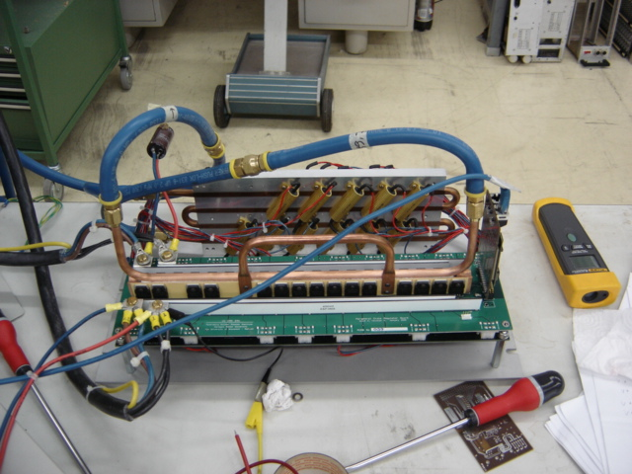

Figure 1 – View of the CRB in the test fixture or dummy load.

The process:
- Chose and inspect a CRB for testing. Make sure that the female hose is connected to the CRB on the mezzanine side and that the male hose is connected to the CRB on the terminal side. These connections need to be tight since they will never be removed. Removing the hoses after attachment may damage the CRB, so don’t do it.

- Attach the CRB to the testing apparatus.

  - Attach the hoses to the pump.

NOTE: Installing and removing a CRB from the test fixture involves connecting or disconnecting the water hoses. Before and during work on the water hoses, it is imperative that the LVPS be switched OFF at the AC input. The AC power distribution box must be switched OFF.

  - Attach the power supply cables to the terminals, making sure that the 4.5V cable is attached to the 4.5V terminals and the 6.5V to the 6.5V. Also make sure that the supply wires are connected to the supply terminal and the ground wires are connected to the ground terminal for each cable. For the testing done so far, the voltages of the terminals were measured to be 6.47V and 4.88V. The input voltages should be measured when beginning each testing session or about once each day.

NOTE: Installing and removing a CRB from the test fixture involves connecting or disconnecting the LV cables. Before and during work on the LV cables, it is imperative that the LVPS be switched OFF at the AC input. The AC power distribution box must be switched OFF.

  - Attach the PCMB to the CRB. Also make sure the PCMB is connected to the computer, and that its power supply is on. There should be three green LED’s visible on the tip edge of the card. The PCMB may be removed, handled and replaced with its own LVPS left on. But be careful not to set the card on a metallic surface as it may short out the power supply.

- Run the program CRB Startup.
  - Enter 10xx for the board number, where xx is the actual board number. The 1000 in the number is to show that the file is the CRB startup file.
  - Follow the instructions given in the GUI. This program will take about 10 minutes to run. At the end of the run, a window will pop up stating whether or not the board passed the test. When the test is done turn off all channels with the GUI and exit the program.
  - The buttons in the GUI are as follows:
    - ‘On’ turns on all channels on the board.
    - ‘Off’ turns them off.

- Run the program CRB Test Run.
  - Enter the board number and click ‘ON’. This will turn on the program, but will not record any data.
  - Click ‘Get Data’ to start taking data.
  - This program will record all voltage data into a text file, but will not record any temperature data. As the test is running, manual recordings of both voltage and temperature may need to be done.
    - The initial tests were done making temperature and voltage readings once per hour. Now that the computer program is fully developed, recordings of both the temperature and the voltage must be done only when a CRB fails the computer tests. These readings should be entered into appropriate spreadsheets.

- After the test.
  - Inspect the output data files. Make sure that they are from the test just run and are complete. If there are problems you may have to repeat one or both of the tests.
  - The CRB hoses are disconnected from the test setup and the water is drained from them. The two hose ends are then connected to each other to keep foreign material out of them during storage and transport.

NOTE: Installing and removing a CRB from the test fixture involves connecting or disconnecting the water hoses. Before and during work on the water hoses, it is imperative that the LVPS be switched OFF at the AC input. The AC power distribution box must be switched OFF.

  - The LV cables are disconnected from the terminals. Be sure to return the brass screws to the CRB.

NOTE: Installing and removing a CRB from the test fixture involves connecting or disconnecting the LV cables. Before and during work on the LV cables, it is imperative that the LVPS be switched OFF at the AC input. The AC power distribution box must be switched OFF.

Details –

Voltages
Lambda settings >>
PCMB supply settings >>

Parameters for the CRB Startup program >
Parameters for the CRB Test Run program >

Data Storage
The data is stored on the local computer in C:/lv in a series of ASCII text files named >

References:

The master version of this document is stored in the web directory:

https://cms-emu-slicetest.web.cern.ch/cms-emu-slicetest/904/Documentation

And is linked from the PC I&C Home Page:

http://cms-emu-slicetest.web.cern.ch/cms-emu-slicetest/904/index.htm

