I.2 DCS Basic Operation

In the fig.10 you see the current EMU-DCS tree: the CMS_CSC node contains folders:

CSC_GAS
CSC_LV
CSC_HV
CSC_WTH (environment conditions folder)
CSC_ME_P1 (ME+1)
CSC_ME_P2 (ME+2)
CSC_ME_P3 (ME+3)
CSC_ME_P4 (ME+4)

Basically you can operate in the following main ways:
- you can switch the whole EMU-DCS or any brunch of it to another state
- you can browse the tree
- you can exclude (disable) or include (enable) a node in the tree so that the node
not to affect or affect the state of other nodes in the tree.
- you can detect and cure alarms

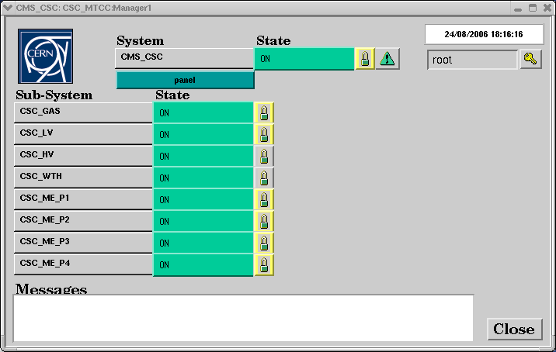
Fig.10

I.2.1 Switching ON the whole EMU-DCS and some browsing:

You may switch on the whole EMU-DCS as shown in the figure.11 :
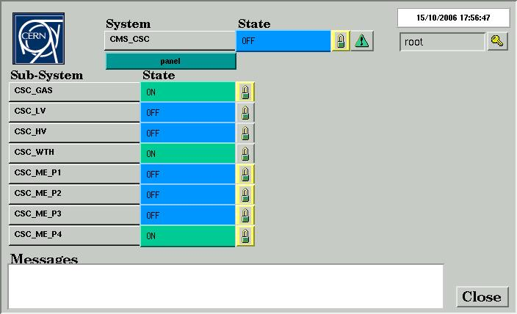
ON
STANDBY
OFF
Fig.11
Click the “State” button opposite the “CMS_CSC” to see the list of possible commands:
Select “ON” to switch ON the whole EMU-DCS.
If you do that you will see the fig.12 , i.e. the nodes CSC_ME_P1, CSC_ME_P2, CSC_ME_P3 still stay in the “OFF” state (until HV ramping is over).
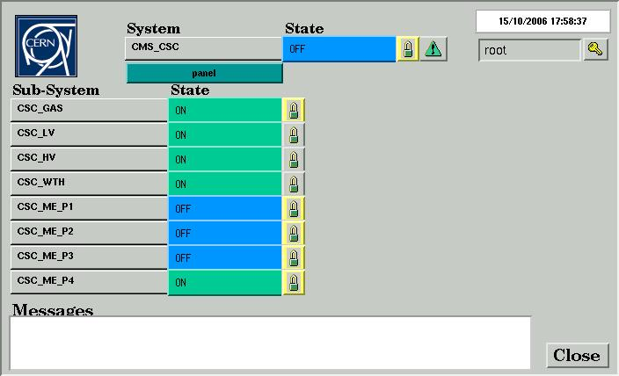
Fig.12

When the HV ramping is over (in a few minutes) we will see the fig.13

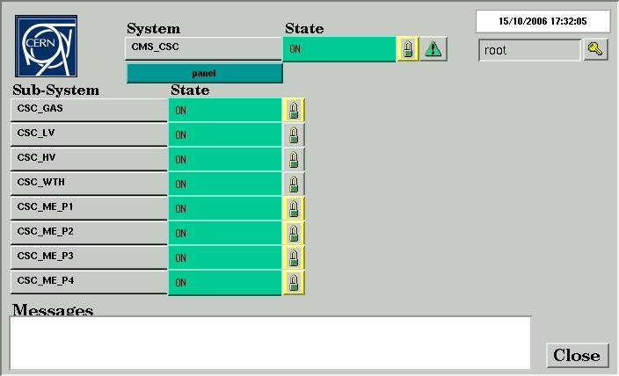
Fig.13
To look at details of what is happening “inside” the tree during the HV ramping you can brows the tree for example as follows:

a) double click the “CSC_ME_P3”
The new window is displayed (fig.14) In particular it contains the chamber nodes of ME+3

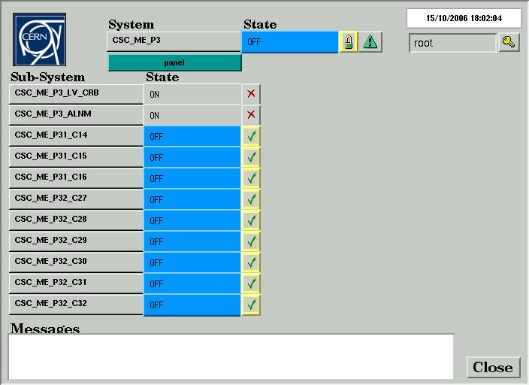
Fig.14

b) double click the “CSC_ME_P31_C14”
The new window is displayed (fig.15) In particular it contains the devices of the chamber
ME+3/1/14

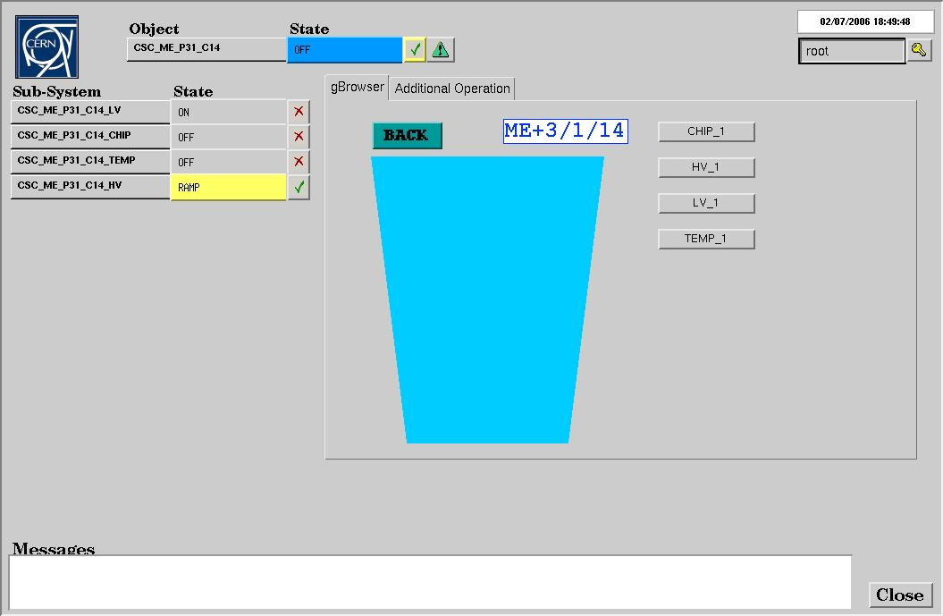
Fig.15

c) double click the “CSC_ME_P31_C14_HV” to see details of HV ramping for the selected
chamber (fig.16)

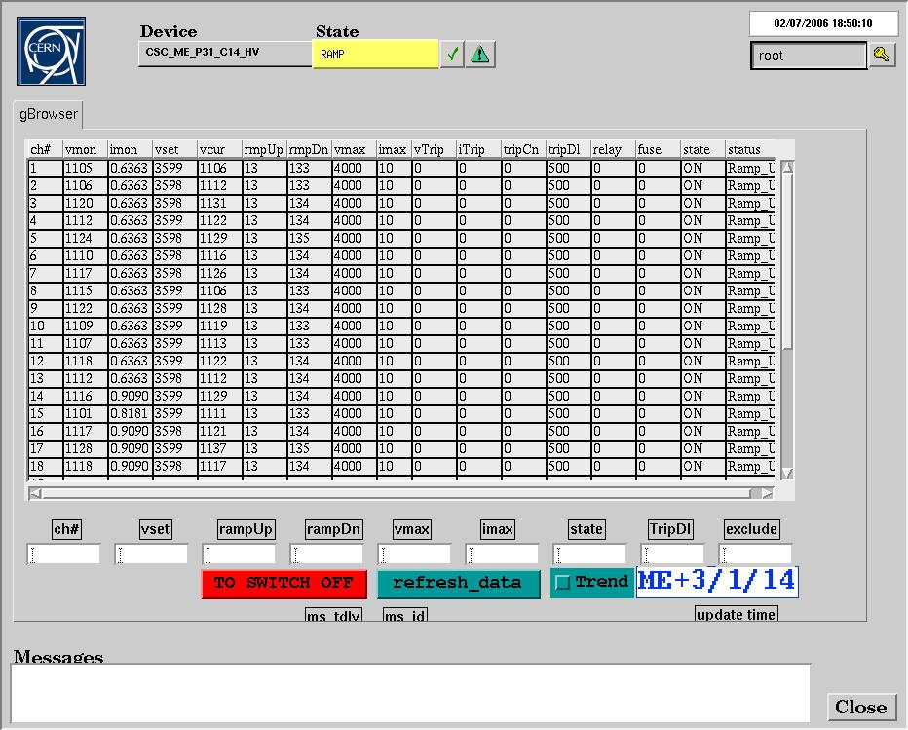
Fig.16
Switching OFF the whole EMU-DCS is not recommended as some Sub-Systems should
stay ON to detect the alarms (gas, weather parameters). See below how to switch OFF particular Sub-
Systems (HV, LV).I.2.2 Switching ON/OFF the particular Sub-Systems (HV, LV, ME stations)

1) Switching ON/OFF the general LV (maratons):
Use the window shown in fig.17 to switch ON/OFF the node CSC_LV:
(click the “State” button opposite the “CSC_LV” node
to display list of possible commands:
Select ON or OFF depending on what you are going to do.)

2) Switching ON/OFF the chambers HV.
At the moment the following is recommended:
Use the window shown in fig.17 to switch ON/OFF the nodes
“CSC_HV”, “CSC_ME_P1”, “CSC_ME_P2”, “CSC_ME_P3”

Fig.17

I.2.3 Detecting Alarms during the DCS operation

During the DCS operation the status of the DCS should be watched.

I.2.3.1 If you detect an SX5 Weather Alarm (display shown in the fig.18)

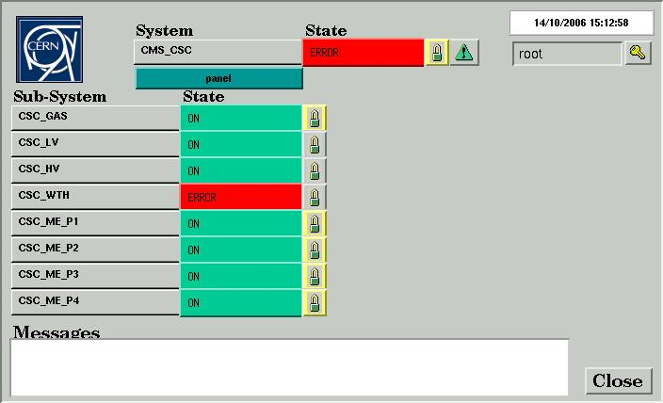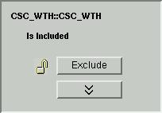
Fig.18a
Fig.18b

do the following: (see fig.18a) Click a “lock” icon of the CSC_WTH (weather station node)
You will see a new popped-up window (fig.18b) Click “Exclude” button to have a display shown in fig.19

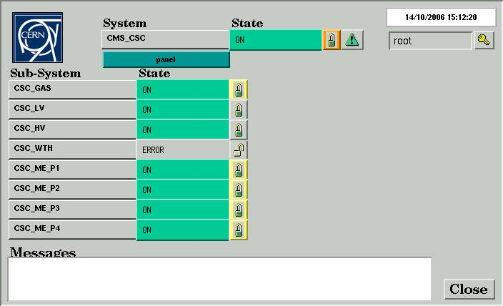
Fig.19

I.2.3.2 If you detect an alarm in CSC_LV node
or in one of the ME station nodes: CSC_ME_P1, CSC_ME_P2, CSC_ME_P3 like shown in fig.20
please do a power cycling (switching OFF then ON ) the alarmed node. If that does not help
(i.e. the alarm is still ON) use the DCS_MTCC_PHASE2_A_HOW_TO_USE_DOCS.doc
which should be used by experts only) or call the DCS expert

Fig.20
ERROR

