Operation with EMU-DCS in Green Barrack.

Starting the CMS_CSC project:

On the “emudcs” machine console go to DCS screen and
open a new terminal and log in as follows:
su – fast (please do not forget the “-“)
User: fast
Pass: UFdqm_04

Issue the command:
DCS
To start the VNC server

Click the small Icon in the middle of the desktop top border.
If you see a new desktop opened please skip the bold line right below:
If a new desktop is not opened, please proceed with DCS command again.

shortly after start you will see two popped- up grey windows (like in fig.1). Please close both of them
by clicking the “Close” buttons
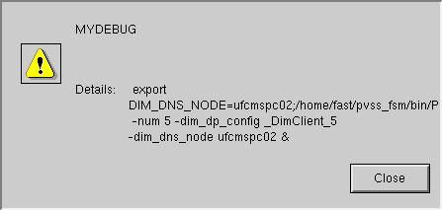
Fig.1

Now wait until the grey window
“START IS COMPLETE
YOU CAN OPERATE” (fig.2 ) is displayed ( in ~ 5 minutes !!! )
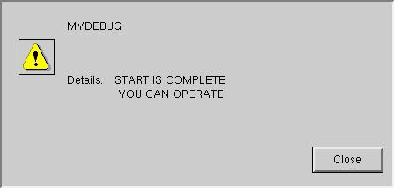
Fig.2
Click “Close” button to close the “YOU CAN OPERATE” window

Identify the window “Device Editor & Navigator” (fig.3)
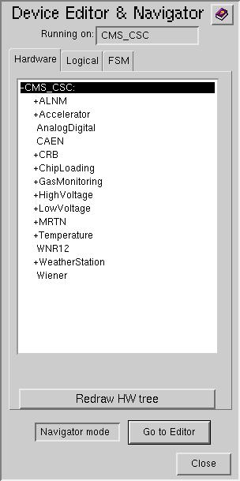
Fig.3
Click FSM tab of the window “Device Editor & Navigator” (fig.4)
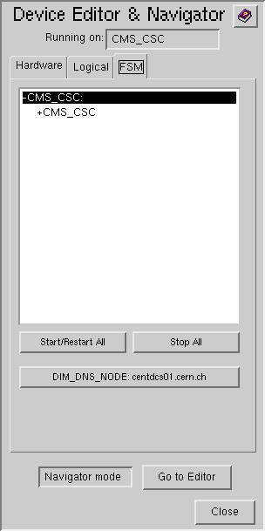
Fig.4

Click “Start/Restart All” and wait until the new popped up window
(Make sure you already got the fig.2 display before to do that)
“Please wait – All Domains Starting Up … ” is closed
Click the +CMS_CSC
so that the +CMS_CSC is highlighted like shown in fig.5
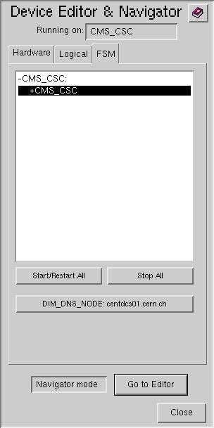
Fig.5
Right click the +CSC_MTCC to display the vertical pop-up menu: (fig.6)
View
Start/Restart node
Stop Node
Start/Restart Tree
Stop Tree
Fig.6
Select the “View” and click on it to display the window shown in fig.7a
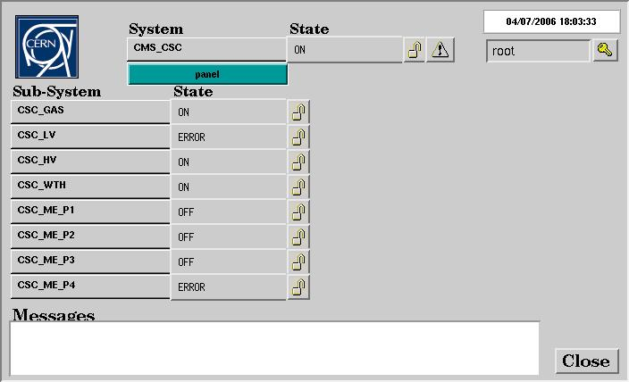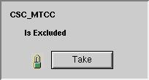
Fig.7a
Fig.7b

Click “Lock” icon to display the “Modes” window like shown in fig.7b
Click “Take” button
And wait the “Modes” window to disappear. Close all popped-up windows (if any) with “Close” button.
(that my take up to ~ 2 minutes! Do not click the window Fig.7a while the “Modes” is displayed!)
When the “Modes” window is disappeared wait for more 2 minutes.
You will see a display like shown in fig8:
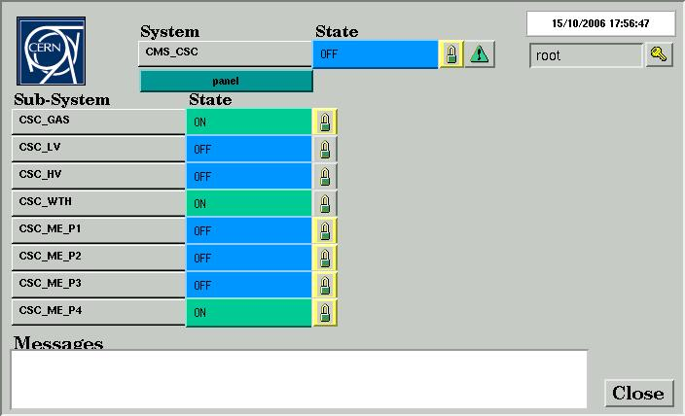
Fig.8

Advanced Information:

1) During the operation if you have a trouble with FSM you may:

Click “Start/Restart All” as shown in fig.4 (to restart the FSM) and follow with figs.5-8

2) During the operation you also may

Click the “Lock” icon of the “CMS_CSC” node to display the “Modes” window like shown in fig.10
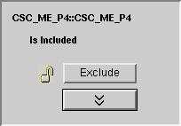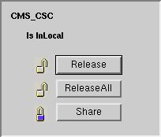
Fig.10

Click “>>” and then the “Release All” button
Wait for the “Modes” window to disappear to get the display like shown in fig 7.a
Then follow with figs.7a - 8

3) During the operation (when the CMS_CSC project is running) you may issue the command:
emudcs_start
(please do that after the proper logon: see the top of the instruction)
The command closes the currently running CMS_CSC project and starts a new one.

