July 3, 2006

Operation with EMU-DCS in Green Barrack.

Level I: operation with CSC_MTCC project:

I.1 Start and initial operation

log on:
machine: emudcs
username: fast
password: UFdqm_04

Issue the command:
emumtcc_start
and wait until the grey window “You can operate” (fig.1b )is displayed ( in ~ 30 seconds)

Click “Close” button on the window: “You can operate” to close it

Identify the window “Device Editor & Navigator” (fig.1a)

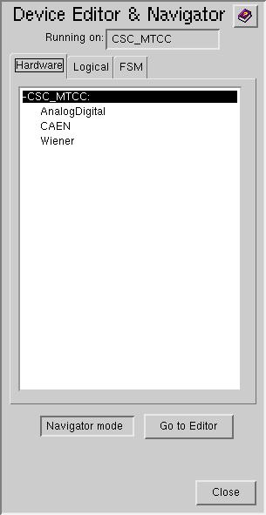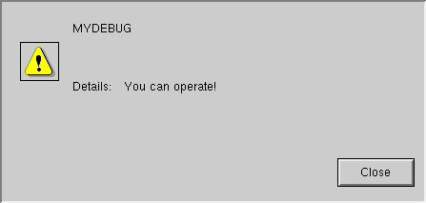
Fig. 1a Fig.1b

Click FSM tab of the window “Device Editor & Navigator” (fig.2)

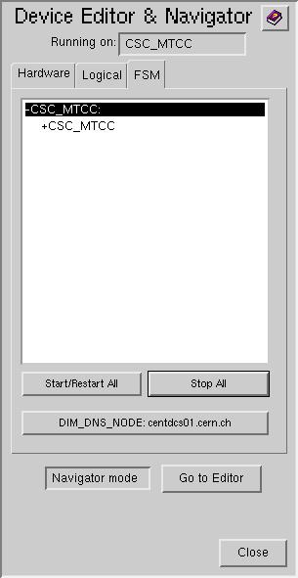
Fig.2
Click “Start/Restart All” and wait until the new popped up window
“Please wait – All Domains Starting Up … ” is closed

Click the
+CSC_MTCC
(the +CSC_MTCC should be highlighted like shown in fig.3

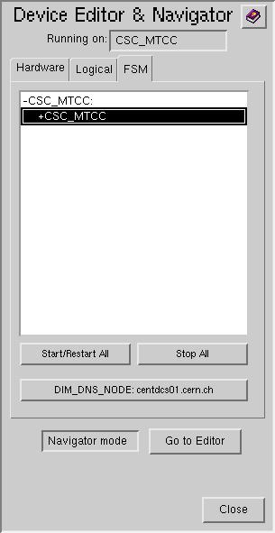
Fig.3

Right click the +CSC_MTCC to display the vertical pop-up menu: (fig.4)
View
Start/Restart node
Stop Node
Start/Restart Tree
Stop Tree
Fig.4

Select the “View” and click on it to display the window shown in fig.5

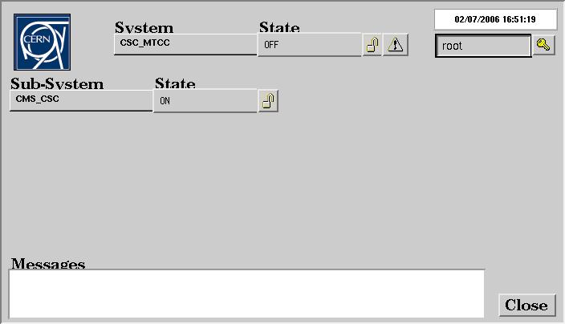
Fig.5

Click “Lock” icon to display the “Modes” window like shown in fig.6
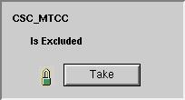
Fig.6

Click “Take” button
And wait the “Modes” window to disappear
You will see fig7:

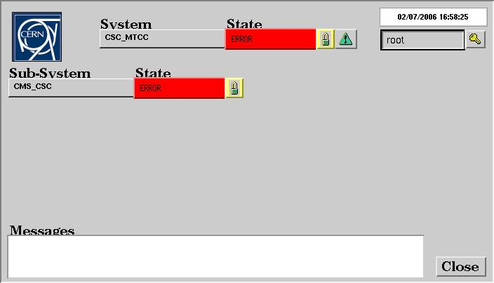
Fig.7

Double click the “CMS_CSC” node to display fig.8:
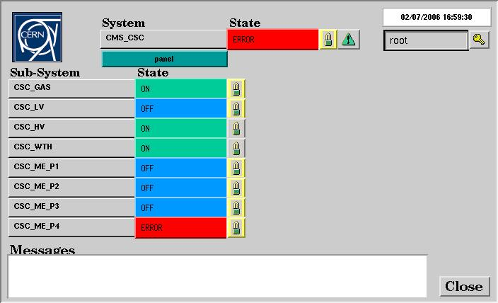
Fig.8

If the “CSC_ME_P4” node is RED (in ERROR state) like in fig.9
click “Lock” icon of the “CSC_ME_P4” node to display the “Modes” window.
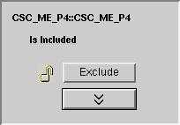
Fig.9
Click “Exclude” to see the fig.10
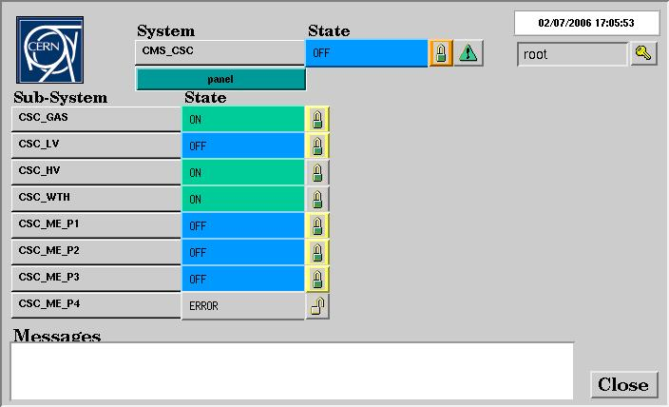
Fig.10

I.2 Basic operation

In the fig. 10 you see the current EMU-DCS tree: the CMS_CSC node contains folders:

CSC_GAS
CSC_LV
CSC_HV
CSC_WTH (environment conditions folder)
CSC_ME_P1 (ME+1)
CSC_ME_P2 (ME+2)
CSC_ME_P3 (ME+3)
CSC_ME_P4 (ME+4)

Basically you can operate in the tree main ways:
- you can switch the whole EMU-DCS or any brunch of it to another state
- you can browse the tree
- you can exclude (disable) or include (enable) a node in the tree so that the node
not to affect or affect the state of other nodes in the tree.

Let’s consider the switching and browsing using the possible ways of the DCS operation during the MTCC:

I.2.1 Switching ON/OFF the whole EMU-DCS and some browsing:

You may switch on the whole EMU-DCS as shown in the figure.11 :
ON
STANDBY
OFF
Fig.11
Click the “State” button opposite the “CMS_CSC” to see the list of possible commands:
Select “ON” to switch ON the whole EMU-DCS.
If you do that you will see the fig.12 , i.e. the nodes CSC_ME_P1, CSC_ME_P2, CSC_ME_P3 still stay in the “OFF” state (until HV ramping is over).
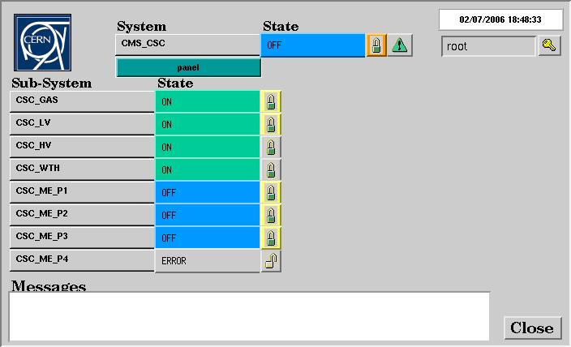
Fig.12

When the HV ramping is over (in a few minutes) we will see the fig.13

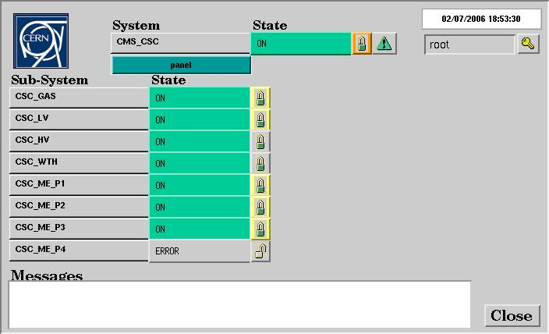
Fig.13
To look at details of what is happening “inside” the tree during the HV ramping you can brows the tree for example as follows:

a) double click the “CSC_ME_P3”
The new window is displayed (fig.14) In particular it contains the chamber nodes of ME+3

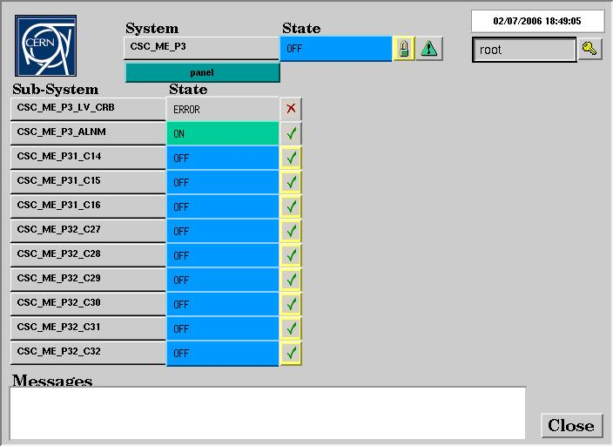
Fig.14

b) double click the “CSC_ME_P31_C14”
The new window is displayed (fig.15) In particular it contains the devices of the chamber
ME+3/1/14

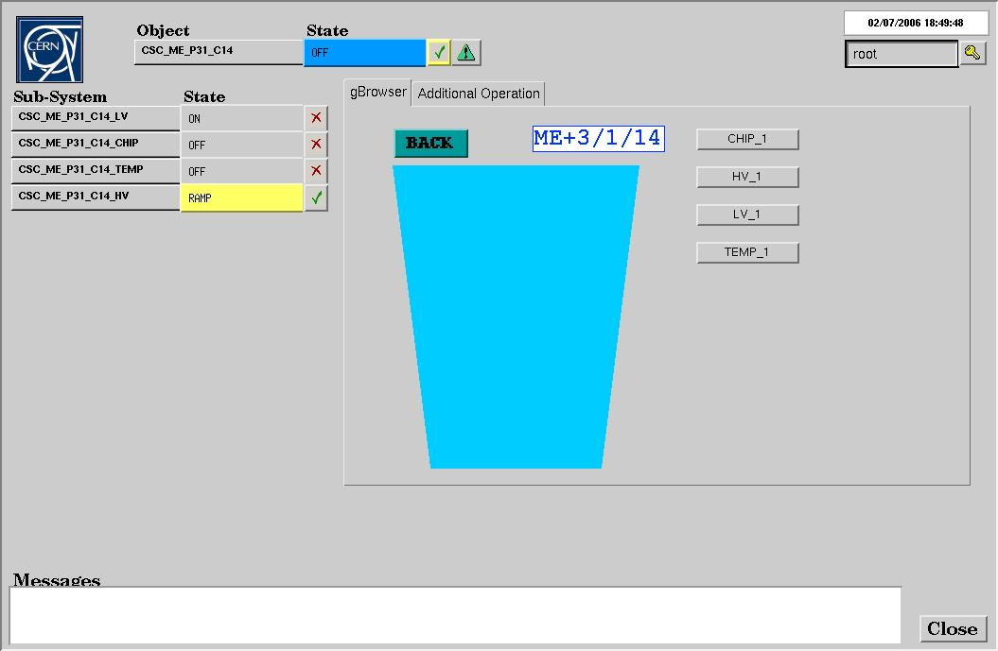
Fig.15

c) double click the “CSC_ME_P31_C14_HV” to see details of HV ramping for the selected
chamber (fig.16)

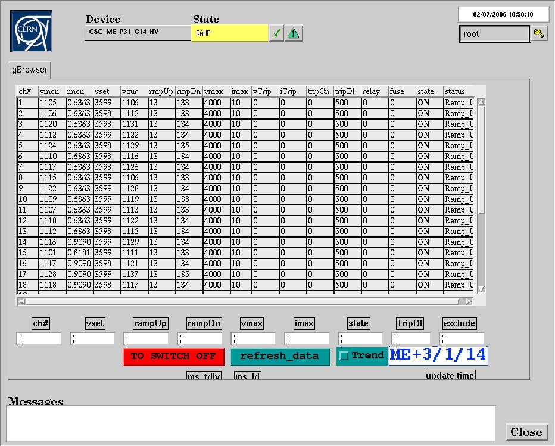
Fig.16
Switching OFF the whole EMU-DCS is not recommended as some Sub-Systems should
stay ON to detect the alarms (gas, weather parameters). See below how to switch OFF particular Sub-Systems (HV, LV).

I.2.2 Switching ON/OFF the particular Sub-Systems (HV, LV, ME stations)

1) Switching ON/OFF the general LV (maratons):
Use the window shown in fig.17 to switch ON/OFF the node CSC_LV:
(click the “State” button opposite the “CSC_LV” node
to display list of possible commands:
Select ON or OFF depending on what you are going to do.)

2) Switching ON/OFF the chambers HV.
At the moment the following is recommended:
Use the window shown in fig.17 to switch ON/OFF the nodes
“CSC_ME_P1”, “CSC_ME_P2”, “CSC_ME_P3”

3) “CSC_HV” (fig.17) contains the general HV (HV primary supplies).
Do not switch OFF the “CSC_HV” unless an emergency situation.
Note that “CSC_HV” should be ON if you are going to execute the (2)(ON),
i.e. to switch ON the chambers HV

Fig.17

