CMS ME CSC HV system

Slice test shift operator instructions.

Alex Madorsky, University of Florida/Physics

madorsky@phys.ufl.edu

Scope of the document
The scope of this document is shown below:
- Powering the system up
- Preparing the system for power cut
- Emergency high voltage shutdown

The actual HV system control (setting the voltages, trip levels, monitoring the parameters) is done via the DCS software. The instructions can be found in the DCS software manual.

People to contact in case of problems:
Alex Madorsky (madorsky@phys.ufl.edu, +1-352-392-9849)
Petr Levchenko (160537)

System components

The HV system components that the shift operator has access to are listed below:

- Primary High-Voltage power supplies (Figure 1).
Each of these modules provides high voltage for one of the Distribution racks located on disks.
- Control computer (Figure 2).
The software running on that computer controls all components of the system.
- Low Voltage power supply (Figure 3).
Provides low voltage power for distribution boards.
- Primary HV power supply control module (Figure 4).
An interface from computer to Primary HV power supplies.

Powering the system up

- Turn on Primary HV power supplies with front panel switches. The voltage and current indicators should light up, and show 0.00 KV and 0.00 mA
- Turn on Control computer with front panel switch. The green power LED above the switch should light up. If it does not, check that the additional power switch on the rear panel of the computer is in the ON position.
- Turn on Primary HV power supply control module. The power switch is located on the rear panel of the module
- Low voltage power supply requires several steps to power all Distribution boards. Read important notes below before proceeding.
  - Press up and hold the power switch (red, see Figure 4), until the display shows “U0 OFF”.
  - Press up “Mode” switch several times, until the display shows “U5 OFF”
  - Press up the power switch again, the display should show “U5 8.00V 10.5A” (the current may vary)
  - Press down “Mode” switch once. The display should show “U4 OFF”.
  - Press up power switch, the display should show “U4 7.00V 8.5A” (the current may vary)
  - Repeat the above operations for channels U3 and U2, and then U10 and U11
  - The voltages on all channels should be as shown below:
Channel | Voltage
U2 | 8V
U3 | 8V
U4 | 7V
U5 | 8V
U10 | 12V
U11 | 12V
If one of the channels displays a voltage different from what is shown in this table by more than 0.05 V, or refuses to turn on - turn off the power supply, call experts.

Important Notes:
  - The turn-on sequence of channels U2-U5 is important. ALWAYS go from U5 down to U2.
  - Pressing “Mode” switch sometimes skips one channel (for example, goes from U5 to U3). Be careful, and in such case press “Mode” switch up once to return to the channel required by the sequence described above.

The system is ready to work. Use the DCS software manual to turn on all voltages on chambers.

Preparing the system for power cut

- Using DCS software, remove voltages from all chambers, wait until it is close to 0V (see DCS software instructions)
- Using the DCS software, turn off the outputs of Primary power supplies (see DCS software instructions)
- Turn off Primary power supplies with power switches on the front panels
- Turn off Primary power supply control module (switch on the rear panel)
- On Low voltage power supply, select channel U11 with “Mode” switch, then press the power switch down and hold it until the display shows “U11 OFF”. Then release the power switch and press it down again, hold until display becomes blank. The LV power supply is off.
- Control computer requires proper shutdown procedure:
  - From any computer with ssh installed, connect to the control computer with the following command: ssh hvuser@ufcmshv1
  - Password: contact HV experts
  - When connected, issue this command: su (use the same password)
  - Issue this command: shutdown –h now
  - Wait for 2 min, and shut down the power of the computer with front panel switch.
The system is ready for power cut.

Emergency high voltage shutdown

Just put front panel switches on Primary HV power supplies into OFF position (see Figure 1)
Power switches

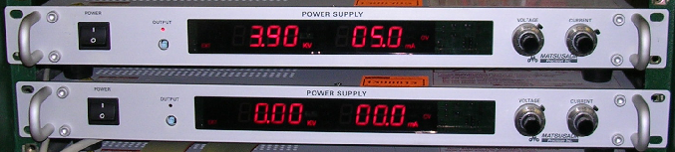
Figure 1. Primary High-Voltage power supplies
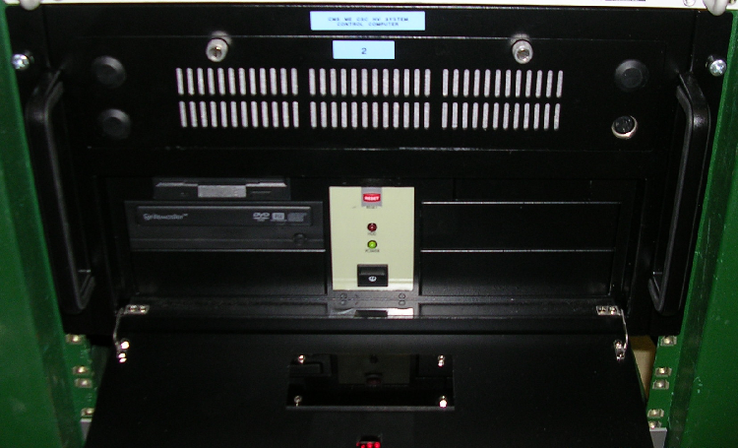
Power switch
Figure 2. Control computer

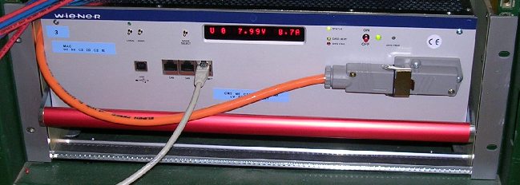
Power switch
Mode switch
Figure 3. Low Voltage power supply
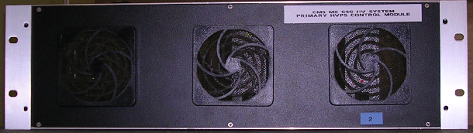
Figure 4 Primary HV power supply control module (power switch on rear panel)

