How to use RecoLocalMuon/CSCStandAlone

Please note: I am assuming no prior knowledge of anything, except for some basic cvs commands, etc.

- Check out the package from CVS. You will need a release area of CMSSW, the list may be viewed by typing (in afs) “scramv1 list CMSSW”. In order for all “older” data taken with the global DAQ to be read, you will either need to use CMSSW_0_8_0_pre3 or before or CMSSW_0_9_0_pre2 or later, due to an incompatibility in the .root files which has arisen in the framework. IF you use 0_9_0_pre2 or later, you will need to make a simple change in the .cfg file, mentioned below.
- Check out the RecoLocalMuon/CSCStandAlone package. It is not version tagged and so you will need actually compile it! Also, you will need to fetch 2 .so files and place them in you CMSSW_version/lib/slc.../ directory. They are libcondbc.so and libcscmap.so from http://cmsdoc.cern.ch/cms/CSC/CERN/dbc_library/ (the user name and password is “EMU” and “CSC” respectively. In addition, for later versions of CMSSW, it has become necessary to also download the setora.(c)sh due to database changes. setora.csh should be placed in RecoLocalMuon/CSCStandAlone/test.
- If you do not wish to do comparisons between S. Durkin's segment finding and T. Cox's segment finding, which I would not expect a shifter to do, then to avoid needing additional packages from cvs, remove from the BuildFile all lines pertaining to RecHitComp.cc and RecFitterComp.cc. Those will not compile without additional packages from cvs, and should not be needed for monitoring data! (I put them in cvs for people who might wish to validate my studies, and also to back them up, but this is not something I expect to be done on-shift!).
- From test, you may now compile! “scramv1 b”.
- Type “source setora”. Though this dependency will hopefully be removed again.
- In test, I provide example configuration files. They are quite simple. The 2 I see as being relevant for a shifter is CSCMonitor.cfg and CSCLocalDAQMonitor.cfg, in which the first is configured for .root (global DAQ) files and the second for local DAQ (.bin) files. You'll need to specify the location of your file(s), and how many events you wish to run over. ALSO, if you are using a version of CMSSW_0_9_0_pre2 or newer, on “older” data (I am awaiting to hear that global DAQ has updated their methods) change the line source=PoolSource to source=PoolConvert. This is a patch which was instigated for us by the framework people.
- Type “cmsRun CSCMonitor.cfg”. The program will execute. And it will create, in CSCStandAlone/test, the file CSCMonitoring.root. This is your file of interest!
- Load this file in root. type “root CSCMonitoring.root”. Once inside root type “TBrowser b”. A window will open.

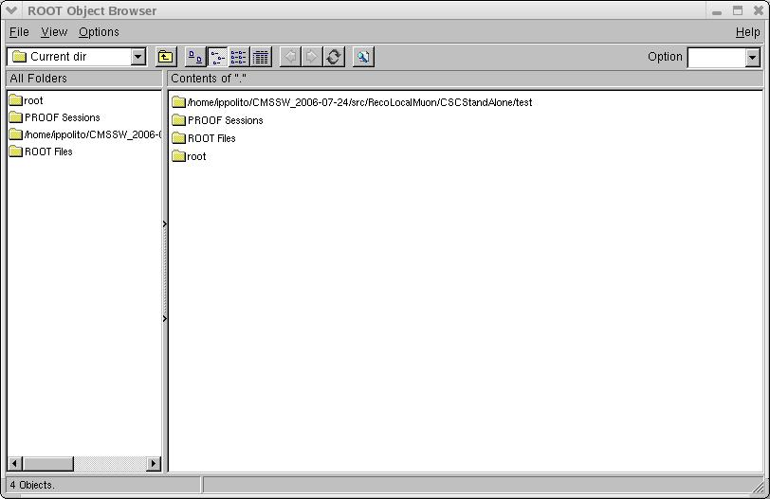

- Double-click on “ROOT files”. You will see this window with “CSCMonitoring.root” in it. Double-click on the “CSCMonitoring.root” icon and you will see:

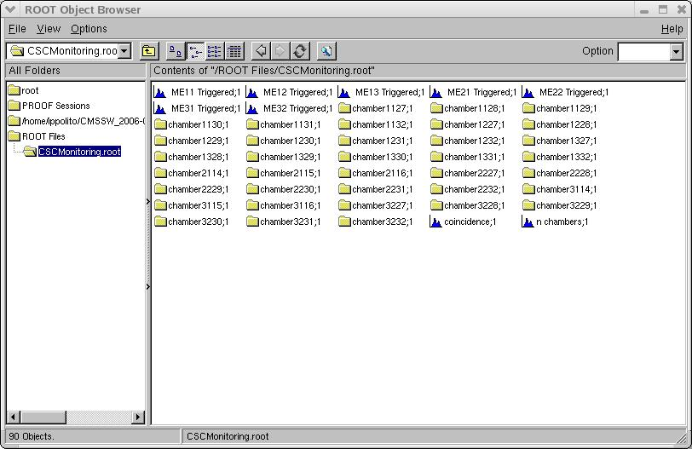
You'll be able to see folder of all 36 chambers, as well as histograms for the frequency of triggering in all the different types of chambers included in the MTCC. Also, the number of chambers which constituted an event. For monitoring purposes, it will tell you if a chamber had any hits. To see how an individual chamber is performing, click on it's icon. For instance, chamber2227 is ME 2/2/27. Double-click on that icon and you will see this menu:
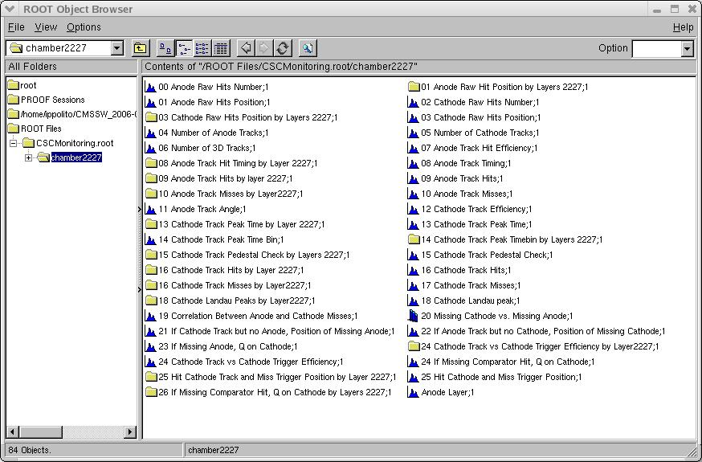
These constitute the various quantities you'll be able to monitor on a chamber. I have tried to make the names as self-explanatory as possible. Some may be more useful then others. For instance, the Landau peak for this chamber, as run over 10,000 events, looks like this:
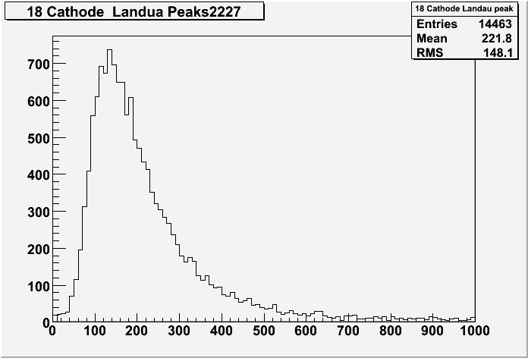
From the other histograms, you can see if a board is missing for instance, if there were to be a large gap in either the “09 Anode Track Hits” histogram or the “16 Cathode Track Hits” then likely a board is missing there.
This code was originally designed to monitor chamber efficiency. Keep that in mind when using it now. If you have any questions feel free to contact me (Nicole Ippolito) about any of the histograms. But I would NOT think that such histograms as “If Cathode Track but no Anode[track]” will be all that critical during the runs themselves.

